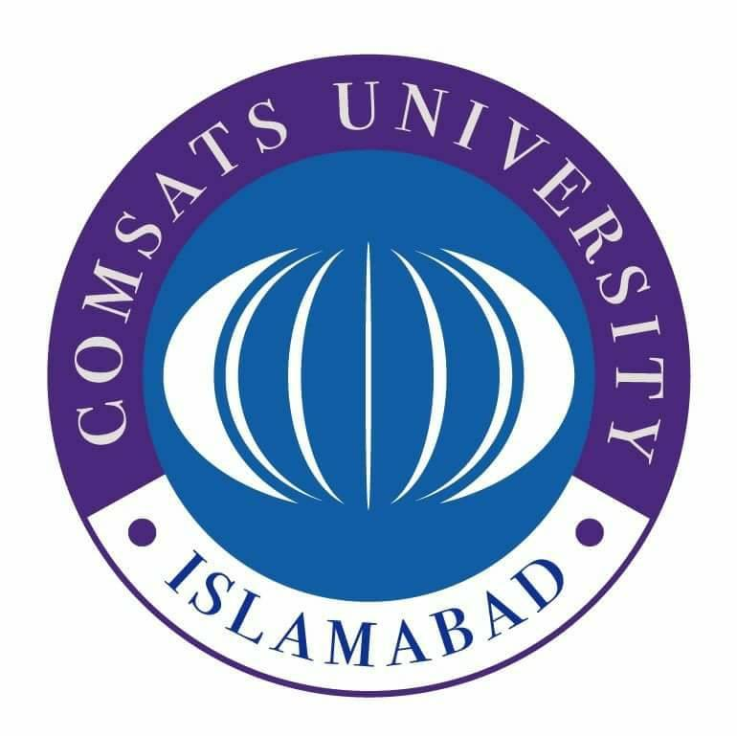

**SUBMITTED BY:** Kulsoom Khurshid

**REGISTRATION #:** SP20-BCS-044

**COURSE:** Pakistan Studies

**SUBMITTED TO:** Ma’am Tooba Aslam

**ASSIGNMENT #:** 1

**Kulsoom Khurshid**

**SP20-BCS-044**

**ASSIGNMENT # 1**

**Question 1)**

**Answer:**

Ideology:

The term “Ideology” has been the subject of disagreement among various Sociologists from the beginning when it comes to its definition and meaning. Different researchers of different time has defined it in their own way. By literal definition, ideology means an outline of thoughts proposed for a nation to achieve any goal or a collective school of thought of a nation on a single schema for a certain purpose.

It is collection of ideas related to an economic, social and political values of a nation along with some positive action program for achieving these goals. It construct a system of human life that includes various theories, objectives and proclamations of life. It tells the person about his background, where he is standing and where we will be in future.

Ideology of Pakistan:

The foundation of the ideology of Pakistan is the Islamic philosophy of life. Muslims are different from other nations on the basis of the Islamic way of life. Ideology comes in society only when people feel their beliefs are under threat or rights not given fairly under existing laws. Same incident happened with the Muslims of the subcontinent after the war of independence in 1857. The Muslims came into the subcontinent as the conquerors. The most fundamental change that occurred in the society at that time was that Hindus had power over the Muslims and Muslims were constantly checked.

Both the groups Hindus and Muslims fought the war for their own interest. Muslims fought to save the Mughal rule as their era was coming to an end and British was taking the control. Whereas, Hindus fought to get their land and businesses back from British. Although, both the groups had similarities in their goals but they were divided in two groups. The Muslims were strong as they were united. After the success of the war Hindus conspired with the British again and only the Muslims were held responsible for the war. This opened the eyes of Muslims. British began to hire men mostly from the groups such as Sikhs, Pathans and Gurkhas who they considered to be trustworthy. The Muslims opposed British education and refused to use English as they thought it to be un-Islamic. After seeing this, British withdrew funding from the Muslims schools which resulted in the decline of their education. At the same time, Hindus favored British by adapting themselves and learning English. Hindus also tried to replace Urdu with Hindi. Therefore, Sir Syed Ahmed Khan is the personality who played very important role during that time. He worked day and night tirelessly for Muslims. He enlightened that Muslims are not only the ones who are responsible for all the circumstances. This is the reason why Muslims demanded for a separate nation.

Pakistan is the country that is purely based on ideology. When Muslims felt that existing ideology is not catering their spiritual and basic rights then the ideology for a separate homeland began. It was the reaction to the Hindus and British who tried to exploits Muslims. It was a riot against the system to save Muslims identity from extinction. It was built and sustained by Muslims nationalism.

**Question 2)**

**Answer:**

The fundamental means of social-cultural interaction is language that can lead to breakdown the societies with cultural diversities. The origin of Urdu language is India. Due to its fertile land and workforce, many invaders came to India for different purposes. As different people from different cultures came into subcontinent, they brought many things along with them including their language. Arabic, Persian and Turkish words mingled with the native people language it gave birth to new language Urdu. It is known as Muslim language and initially it was called “Musalmani”. It was spoken by everyone and large number of literary work was done in Urdu. With the decline in Mughal rule, Hindus and British considered Urdu as invaders language. Both the parties intentionally made efforts to get rid of Urdu. Hindi emerged in 19th century to replace Urdu.

**Sir Syed Ahmed Khan:** Sir Syed Ahmad Khan was a great advocate of Hindu-Muslim unity before the Hindu-Urdu controversy. But then he realized the two nations can never live together as one nation. He build a society to support Urdu and to build the relations between the Hindus and Muslims that suffered during this Controversy. Sir Syed Ahmed Khan responded to Hindus demand by saying that if a nation's language is in danger due to other nations in the region, it is unwise to live with them. So Sir Syed Ahmed Khan, began to focus only on the cause of Muslims. Articles on the significance of Urdu appeared in his Scientific Society Gazette. Muslim newspapers, such as Noor-ul-Absar and Banaras Gazette, also pledged to protect their language. In 1871, the Lt. Representative of Bengal G. Cambell prohibited Urdu within the area at all levels. This encouraged Hindus in other locales like NWFP, Punjab, Behar, U.P, Sindh, and Oudh etc. to counter Urdu there as well. Gatherings were held that supported the cause of end of Urdu. In 1882, amid the visit of Seeker Commission, Hindu organizations once more attempted to assault Urdu. They held gatherings with its chairman, Dr. Seeker and tried to drive him to confess Urdu as the outside language and to declare Hindi as official language. But in this mission they remained unsuccessful due to the steady actions of Sir Syed and his comrades. The conditions turned out to be significantly more hard for the Muslims and their language when Anthony MacDonnell turned into the legislative leader of UP in 1900. He supported Hindus over Muslims. So subsequent to turning into the lead representative he excused Urdu as the authority language of UP, which was viewed as the home of Urdu language. He gave orders and declared Hindi as authority language of the area. Sir Syed's replacements at Aligarh, essentially Nawab Mohsin-ul-Mulk, the Secretary of the Aligarh Trust, made a move against MacDonnell’s protest. He needed a famous social event of the allies of Urdu at Aligarh and straightforwardly criticized MacDonnell’s work. He likewise established Urdu Defense Association and it was concluded that the affiliation would make moves against the doings of the MacDonnell. At that MacDonnell blew up and undermined Mohsin-ul-Mulk that assuming he'll proceed with his hatred against the doings of the public authority MacDonnell will make sure that Aligarh would stop to get government awards. As the awards were essential for the organization and Mohsin-ul-Mulk couldn't part himself from the safeguard of Urdu, to save Aligarh College he surrendered. In any case, that didn't prevent him from protecting Urdu and proceeded with his endeavors. This results in Urdu as authority language too alongside Hindi of the area. However, Mohsin-ul-Mulk was not happy with this result and proceeded with his battle. When UP disposed of MacDonnell, he established another affiliation called Anjuman-e-Tarraqi-e-Urdu to counter all future endeavors of the Hindus and the English against Urdu.